

Demonstration of Proposed Features

Date | 15 March 2026
Project Name | FinWise AI: Intelligent Loan Eligibility, Credit Analysis & Financial Advisory Platform
Maximum Marks | 1 Mark

Demonstration of Proposed Features

List each feature proposed in the solution and confirm whether it was demonstrated in the final project, along with supporting evidence and remarks.
S.No | Proposed Feature | Demonstrated  (Yes/No) | Screenshot /  Evidence Link | Remarks
1 | Loan Eligibility Checker | Yes | 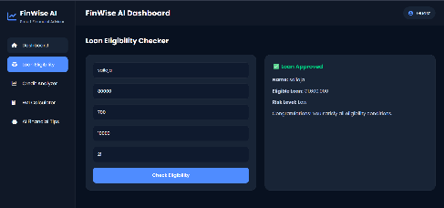 | Successfully checks loan eligibility based on user inputs.
2 | Credit Score Analyzer | Yes | 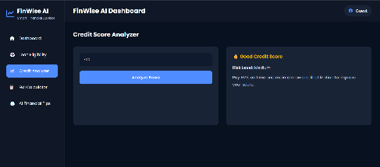 | Displays credit score category and financial risk level.
3 | EMI Calculator | Yes | 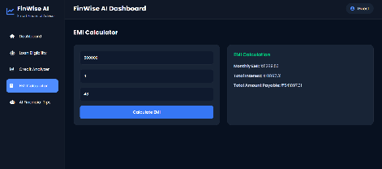 | Calculates monthly EMI, total interest, and repayment amount.
4 | AI Financial Advisor (Gemini API) | Yes | 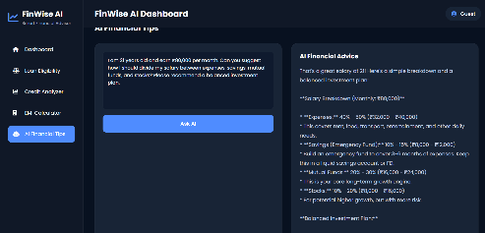 | Generates personalized financial advice using Google Gemini AI.
5 | Responsive Dashboard & Navigation | Yes | 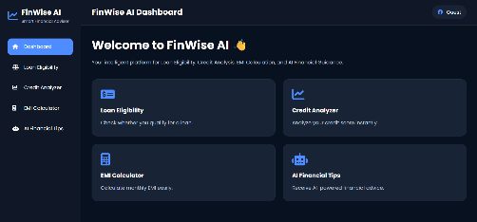 | Provides an intuitive and responsive user interface.

